**Assignment 2: 95313**

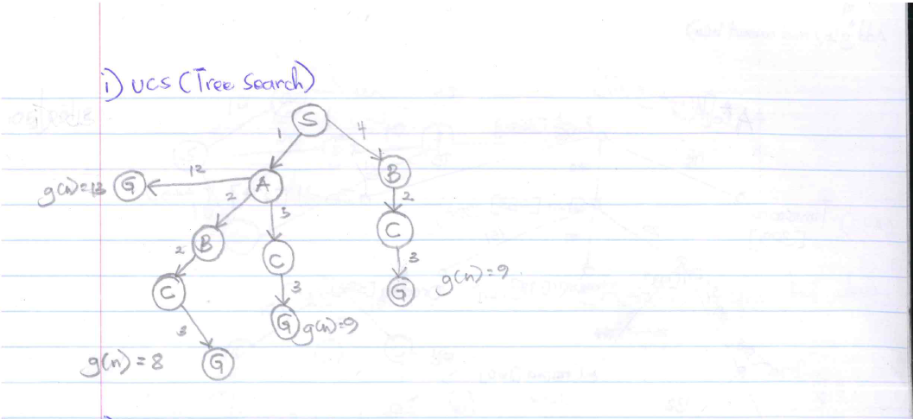

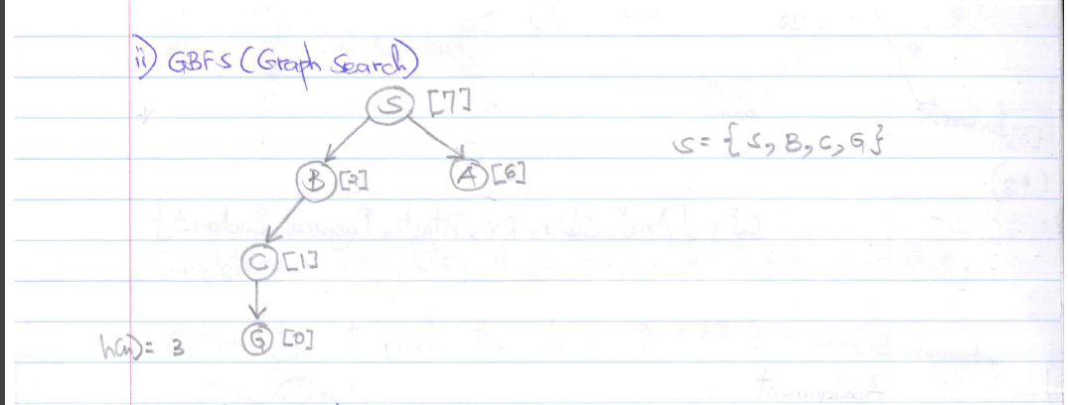

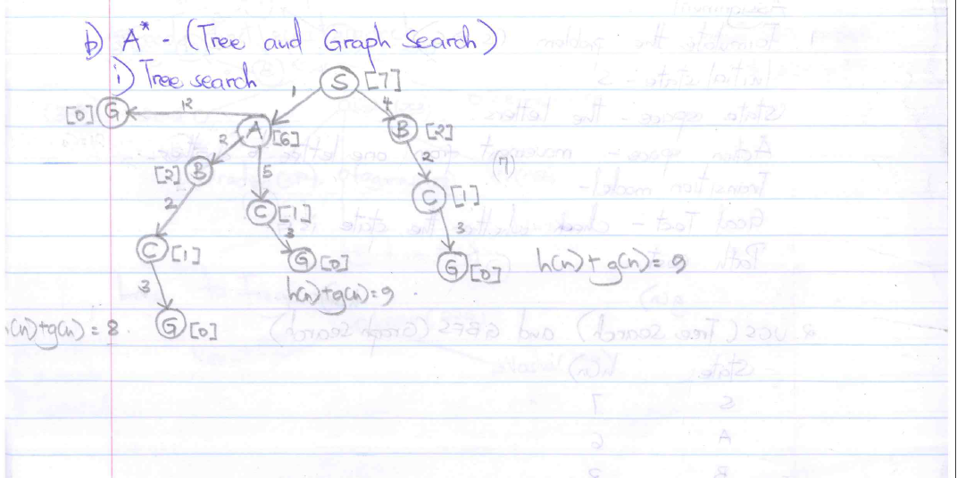

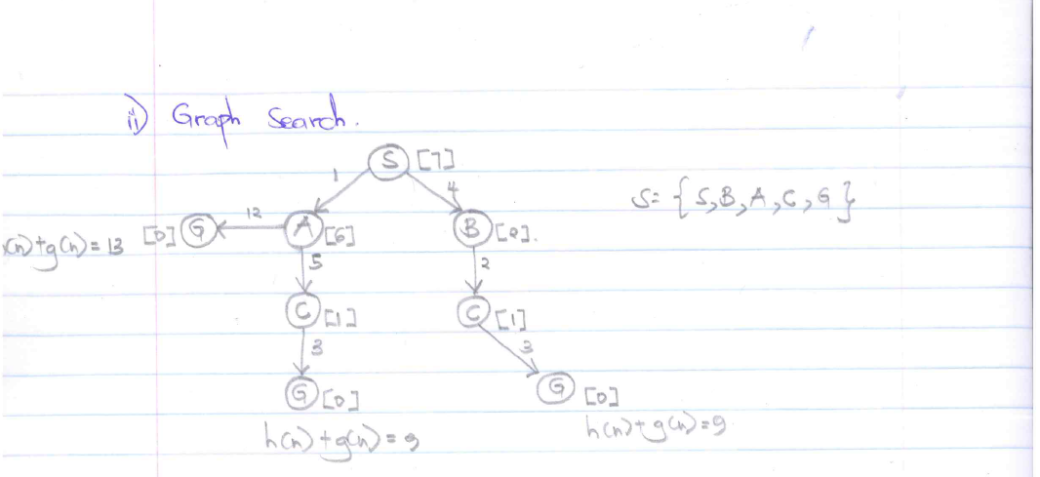

**Question One**

Initial State- S

State space- All the letters attainable from S to G by any sequence.

Action space- Driving, Walking

Goal Test- Check whether the current state is G

Path Cost- The distance between different states, for example the distance between S and A

**Question three**

The solutions for A* graph and tree search in 2(b) above are not the same

**Question four**

In a graph search, the states are not repeatable unlike in a tree search. The path from initial state S to G is longer in the tree search than in the graph search. That is, S-A-C-G in graph search and S-A-B-C-G in the tree search.